Hi Sunny –

I think the newest template site is looking really good. I definitely would like to keep iterating on it to improve it further.

I have some ideas below that I would like to try to implement. I’ll do my best to explain:

1 – Header section

I’ve been trying to think of some good ideas for how to take advantage of the top header section (which is currently blank). I considered reducing the size of it to minimize the space… but I’m instead more interested in finding a way to utilize it as I like that it’s a pretty unique concept as far as websites go.

Here's what I’m thinking… I’d like to try and mimic the homepage of: <https://squeezemetrics.com/>

You will see that their homepage is all gunmetal gray and only has a couple features. I like this minimalization concept. Let’s try to implement that same concept on our site in just the header section. Can we do the following?

1. Can the background of the entire area be changed to the dark gray color we’ve been using in other areas of the site? (this will likely drown out the social media icons, but that’s ok for now, we can come back to those later)
2. Can two buttons be made that have a similar animation effect when hovered over with the mouse cursor? The format will preferably be the same as what’s utilized on squeezemetrics…
   1. The buttons default fill color will be a slightly lighter gray than the one we’re using across the site
   2. The borders of the buttons will be rounded a little bit
   3. The default text color will be white
   4. When hovered over, the colors of the buttons will inverse… meaning, the fill color will be white and the font will be gray

For the buttons themselves, can they please be the following:

1. “See the Cyclical Strength Index”
2. “Read the Current Forecast”

When “See the Cyclical Strength Index” is clicked, the page will scroll down to the Current CSI section using anchor links. Let’s not link the second button to anything yet. I have some ideas for that one, but I don’t have the PDF file ready to be linked to the site yet… so the button will in effect just be a placeholder for now.

I’ve created a mockup below of what our header section could look like:

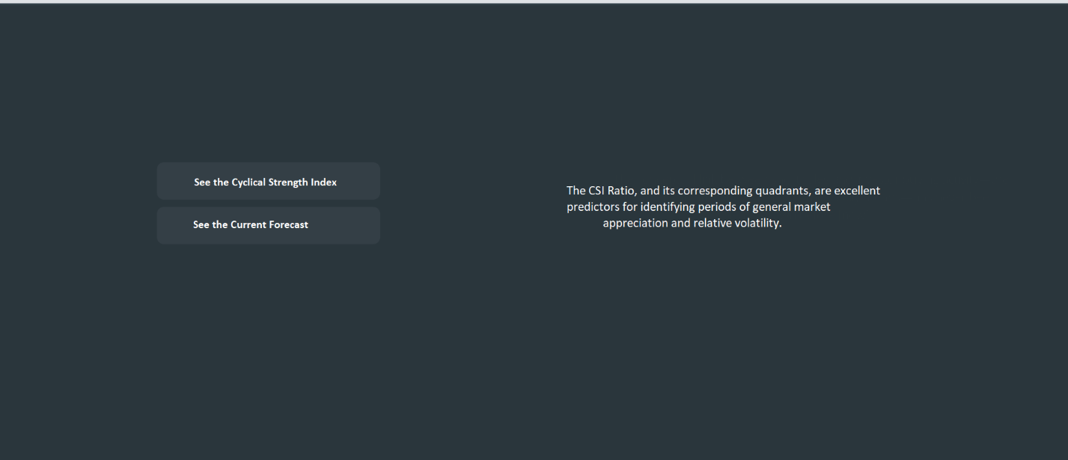

As you can see in the mockup, there is some text that is appearing on the right side of the screen. The text is animated and cycles between multiple quotes. I put together an equivalent for us to use that will cycle between three quotes. I saved it as a .gif – I plan on upgrading the quality and effects of the animated gif… but it should hopefully work well for testing purposes. I opted for a gif as I figured this would make responsiveness easier (although I could be wrong about this of course).

I’m hoping that our version can scale down to mobile in the same way that squeezemetrics site does where when displaying on mobile, the two buttons are on the top half of the screen and the quotes are on the bottom half of the screen.

Nav bar –

I think the updated navigation bar with only fewer links is an improvement and simplifies things a bit. Can we make the following adjustments to it please?



Can the home button be eliminated? Instead, clicking on the CSI logo will now take you to “home” via an anchor link. Then, can the colors for the four remaining buttons (Current CSI, About CSI, Proof Points, and Deeper Dive) be changed to the four colors we have attributed to each CSI quadrant? (Green, yellow, red, blue).

Page Responsiveness –

Please see the screenshot below. I’m not sure if this one is possible but would be preferable to have the nav bar automatically hidden (barely) upon the site initially loading. But, that this be done per the responsiveness settings so that the nav bar is quite literally just below the part of the page initially visible upon load.

